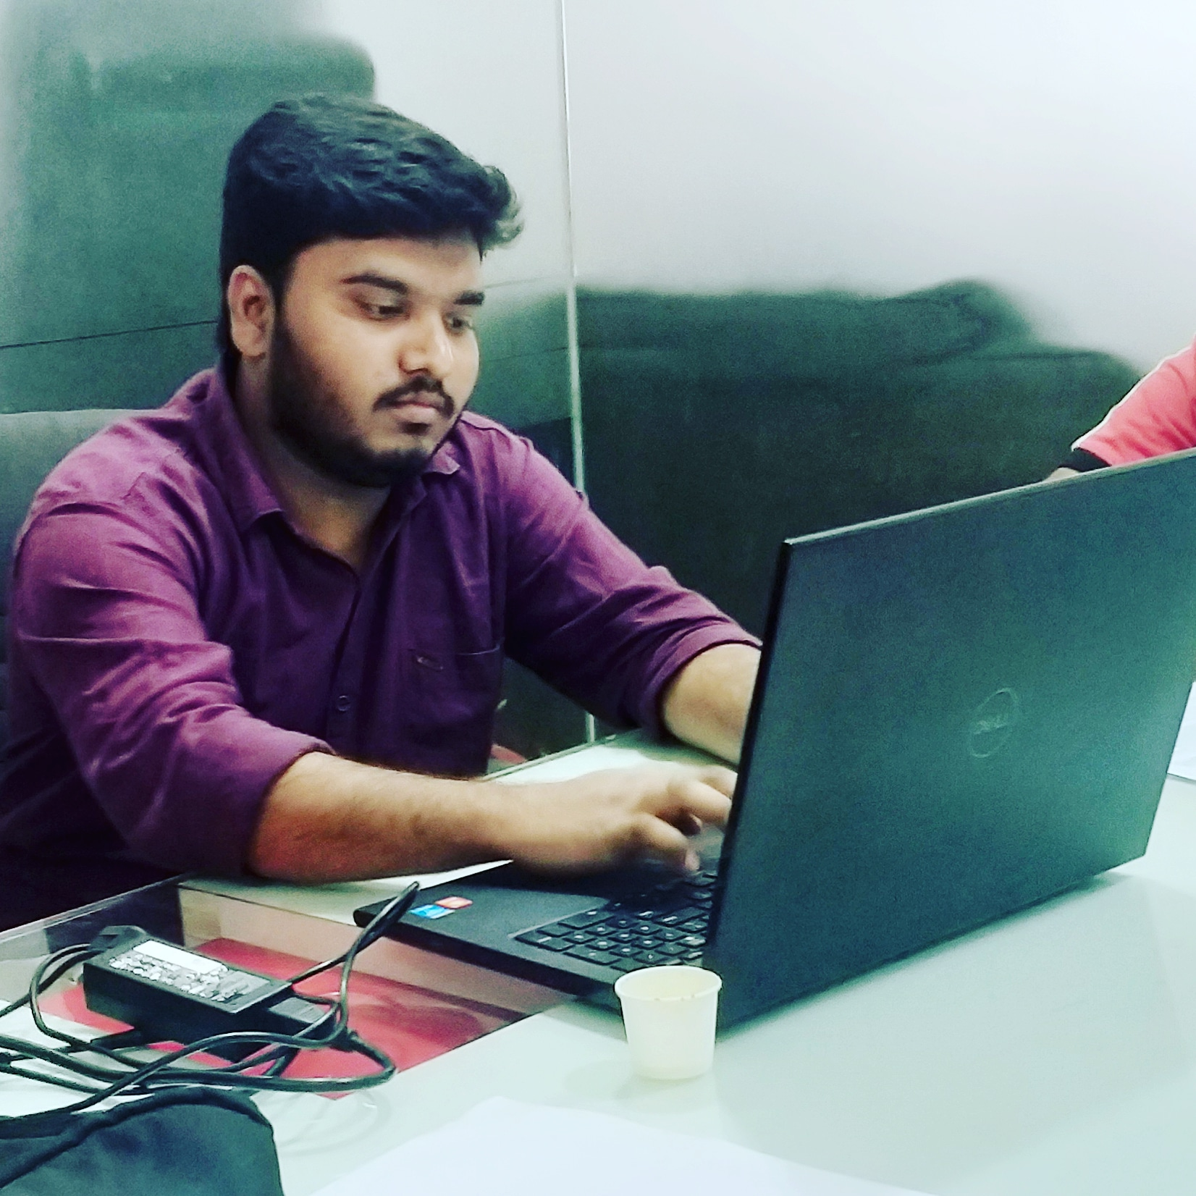

Hussain basha ondla

Professional Summary

A technology consultant with a proven ability to analyze patterns and trends in order to identify issues and areas of improvement. Committed to maintaining high standards within a fast-paced environment; detailed, organized, and able to prioritize tasks for self and others. Combine key methodologies with creativity and insight to produce exceptional results for clients.

# Experience

**Celkon Impex Pvt Ltd – SAP SD consultant ( DISTRIBUTION MANAGEMENT AND SALES IMPLEMENTATION Consultant)**

**Hyderabad, Telangana . 04/2016 - 11/2017( 1.7 years )**

**Manages small teams and/or work efforts (if in an individual contributor role) at the client**

**Understands the strategic direction set by senior management as it relates to team goals**

**Primary upward interaction is with direct supervisor, project or program manager**

**Make decisions that will often impact the team in which they reside**

**Adapt’s existing methods and procedures to create possible alternative solutions to moderately complex problems**

**Determines SAP best practice methods and procedures**

**SAP DMS (DEALER MANAGEMENT SYSTEM)CONSULTANT (SAP & SIBLE) @ 3i infotech consultant PVT ltd**

**3i Infotech Pvt Ltd - SAP DMS (DELAR MANAGEMENT SYSTEM) Consultant**

**Hyderabad, Telangana · 12/2017 - Current**

**SAP functional related**

# Education: 2012-2016 (b.tech)

**Bachelor of Technology _Electrical engineering-**

**JNTU HYDERABAD**

# Certifications

**PHP Framework (certificate):** SAP SD AND SAP CRM AND SAP DMS, DELAR AND DISTRIBUTION MANAGEMENT

SYSTEM

**Programming Languages:** basic c programming language

**Phone:**

9502669676

**E-Mail:**

**Hussainbasha9502669676@gmail.com**

**Linkedin:**

https://www.linkedin.com/in/basha-🤫-70a602b3

# Skill Highlights:Strong knowledge of relevant SAP module

* Good understanding of integration with other SAP modules
* Proven ability to work creatively and analytically in a problem-solving environment
* Understanding of ASAP and experience in delivering solutions within ASAP methodology
* Experience in SAP- functional modules (MM, SRM,FI/CO, IM, LO, SD, PS, HR, PM, OM, TE, PD)
* Completed at least 1 significant full systems implementation lifecycle
* Completed solution configuration for primary module
* Languages

Telugu

Hindi

ENGLISH

Urdu